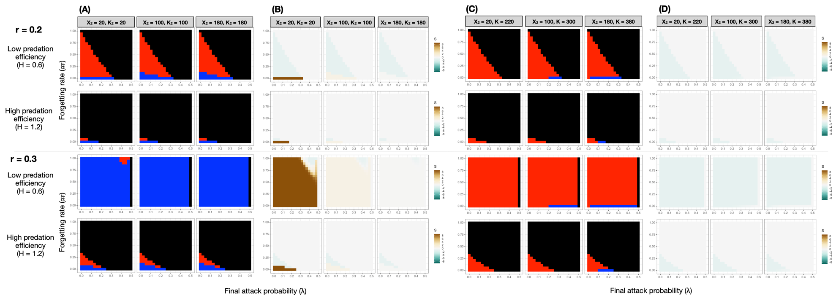

**Figure S1.** Signal persistence (A, C) and corresponding selection (B, D) on the rare signal, with respect to final attack probability (𝜆, x-axis) and forgetting rate (𝛼F, y-axis). Plots are organized based on the intrinsic rate of increase (*r*), per capita predation pressure (*H*). Columns in (A-D) are results when the rare signal was initially 10%, 50%, and 90% as abundant as the common signal. Black cells in (A) and (C) denote the extinction of both signals, red cells denote the extinction of only the rare signal, and blue cells denote the persistence of both signals. In (B) and (D), green colors indicate negative selection on the rare signal, brown colors indicate positive selection, and gray color denotes a selection value of zero. (A) and (B) are when prey have separate carrying capacities, and (C) and (D) are when they share the same carrying capacity. The results here are from simulations where the carrying capacity of the rare prey were set to be the same as the common prey despite its initial minority.

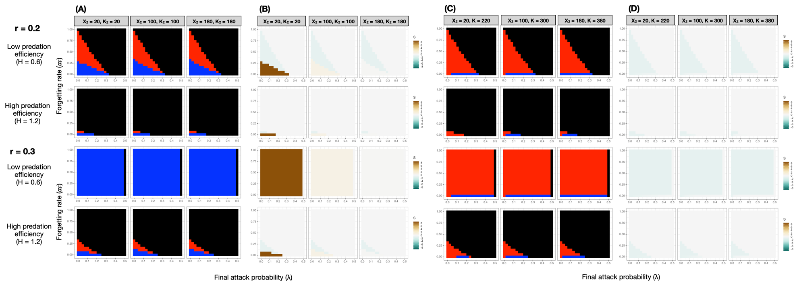

**Figure S2.** Signal persistence (A, C) and corresponding selection on the rare signal (B, D), with respect to intrinsic rate of increase (*r*), per capita predation pressure (*H*), and the initial abundance of the rare signal (10%, 50%, and 90% relative to the common signal) when there is generalization (G = 0.5, see main text). Generalization facilitated local warning signal diversity in all scenarios, especially when the ecological conditions were already favorable (e.g., high intrinsic rate of increase and low per capita predation pressure). The organization of the plots and coloring of the cells are the same as in Figure S2. . (A) and (B) are when prey have separate carrying capacities, and (C) and (D) are when they share the same carrying capacity. As in Figure S2, results are from simulations where the rare prey could be as abundant as the common prey despite their initial rarity.

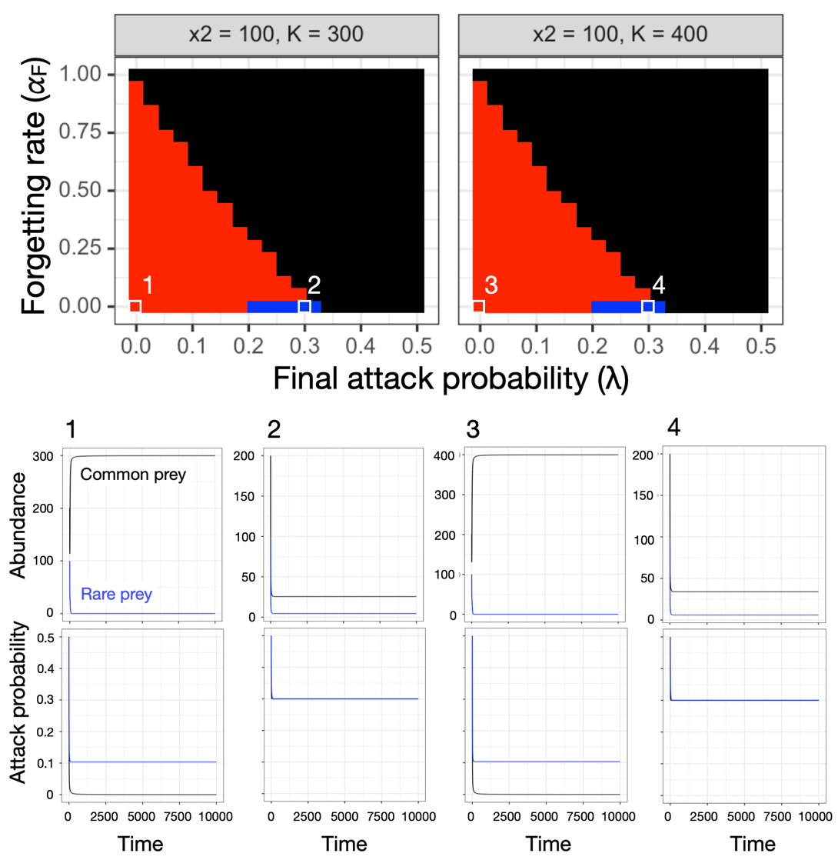

**Figure S3.** Signal persistence under a shared prey carrying capacity. Rare signal were driven to extinction in conditions 1 and 3, in which predation was the weakest due to high predator avoidance and long-lasting memory. In conditions 2 and 4, predation offset competitive disadvantage against the rare signal under low predator forgetting rate and intermediate values of final attack probability. The results were qualitatively identical with higher shared carrying capacities; only the steady-state prey abundances differed.

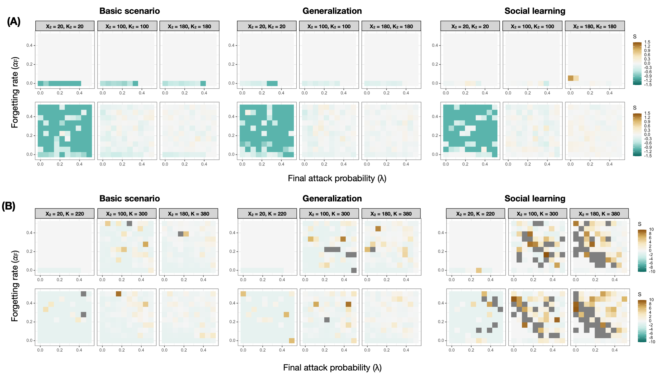

**Figure S4.** Selection on the rare signal with respect to final attack probability and forgetting rate in the individual-based simulations under the basic scenario, with generalization, and with social learning. (A) Selection on the rare signal when prey have separate carrying capacities (B) Selection on the rare signal when prey share the same carrying capacity. Within (A) and (B), plots in the top panel are from simulations with *r* = 0.2, and those in the bottom panel are with *r* = 0.3. Dark gray denotes selection values on the rare signal higher than 10.

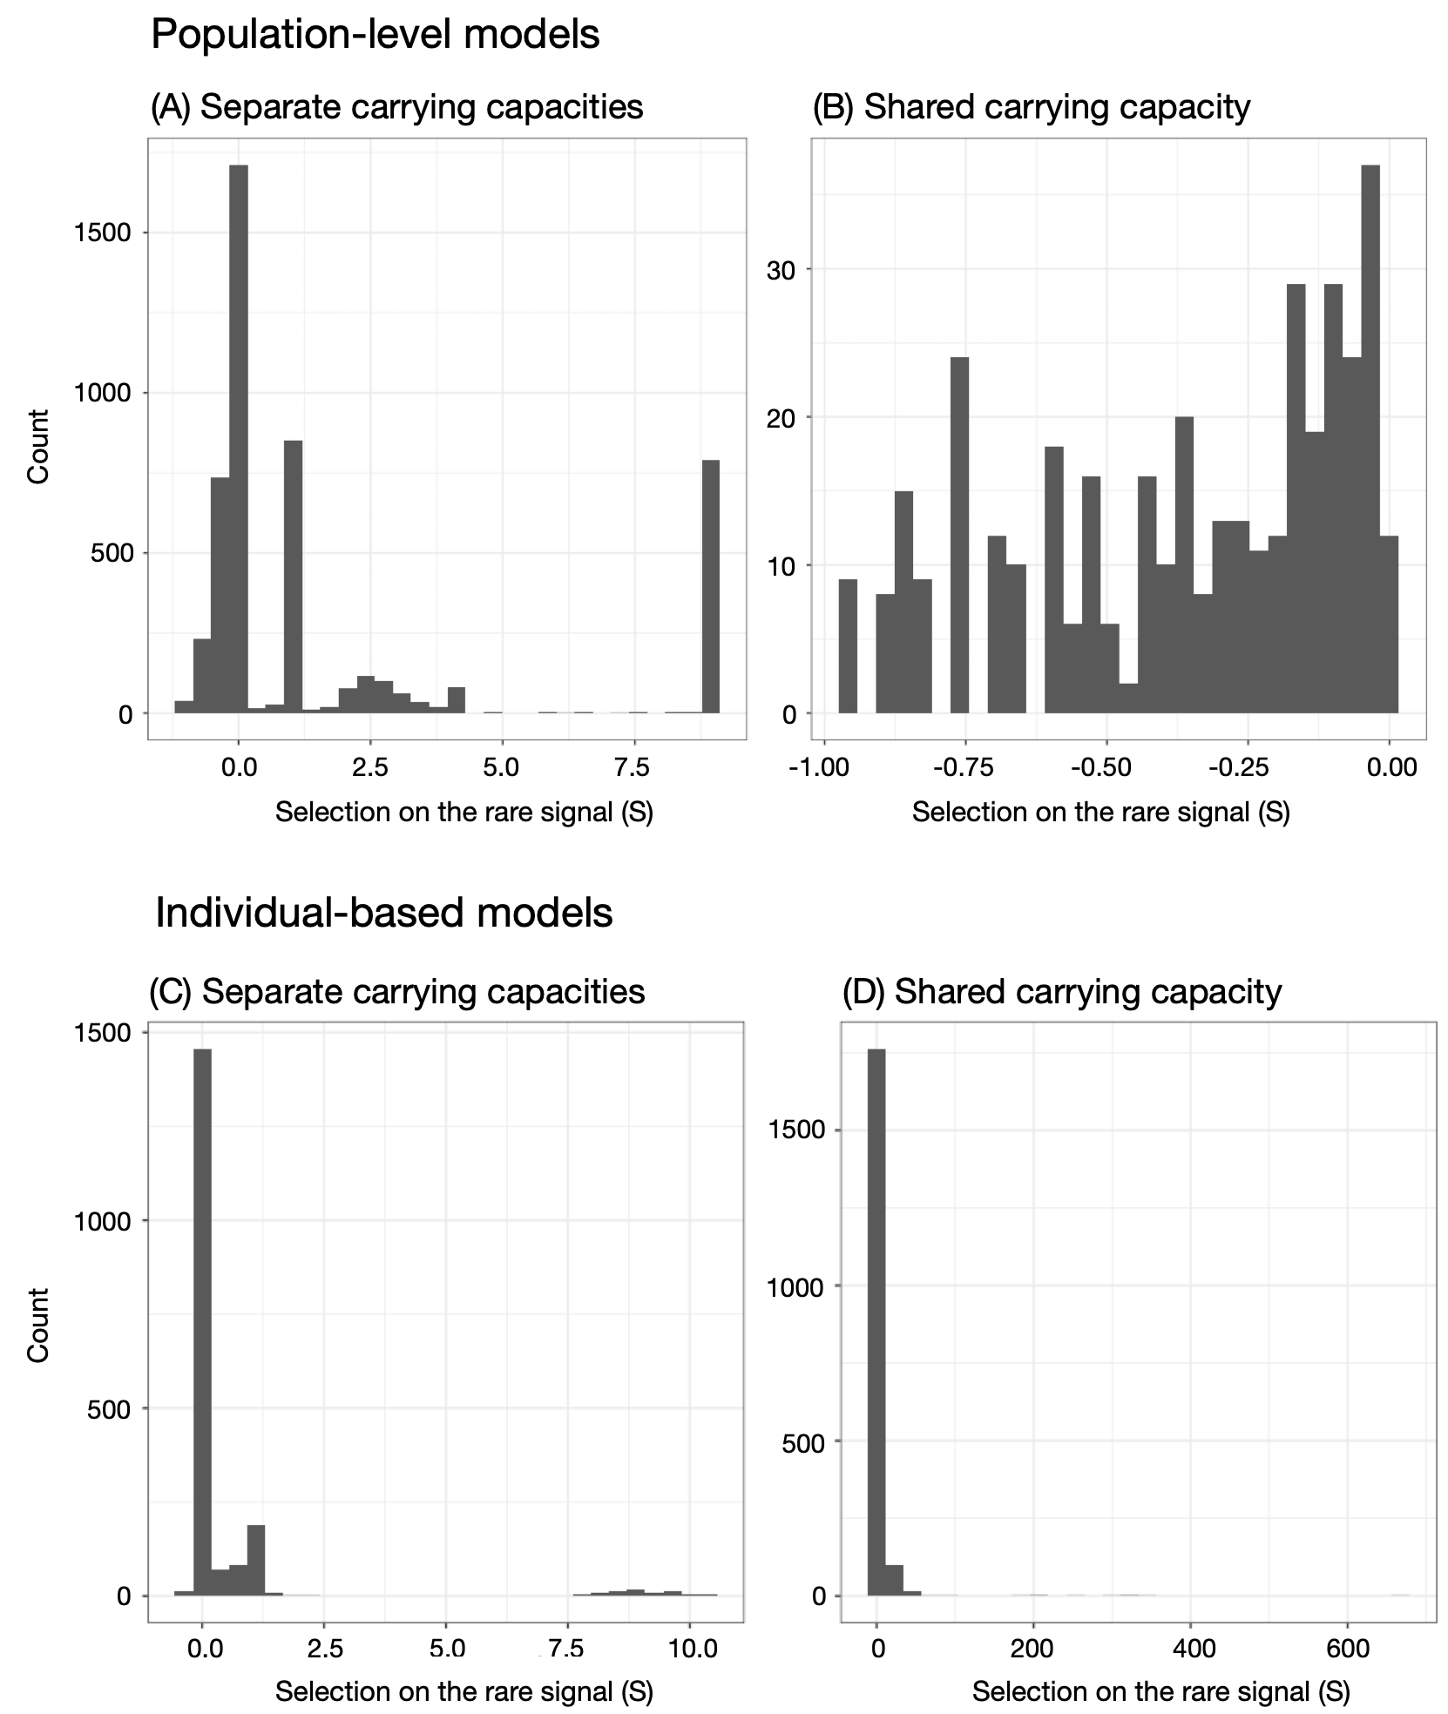

**Figure S5.** Distribution of selection values on the rare signal when it persisted in the population-level model (A, B) and the individual-based models (C, D), when prey had separate or shared carrying capacities.

**Table S1.** Empirically measured final attack probability () and forgetting rate (𝛼F) from selected predators used in Figure 2.

|  |  |  |  |  |
| --- | --- | --- | --- | --- |
| **Species** | **Taxon** |  |  | **Source** |
| *Habronattus pyrrithrix* | Arachnid | 0 | 0.011 | (Taylor *et al.* 2016) |
| *Thalassoma bifasciatum* | Fish | 0.05 | 0.5 | (Miller & Pawlik 2013) |
| *Thalassoma bifasciatum* | Fish | 0.165 | 0.5 | (Miller & Pawlik 2013) |
| *Galls gallus domesticus* | Bird | 0.256 | 0.006 | (Siddall & Marples 2008) |
| *Parus major* | Bird | 0.118 | 0.009 | (Lindström *et al.* 2006) |
| *Parus major* | Bird | 0.119 | 0.026 | (Lindström *et al.* 2006) |
| *Parus major* | Bird | 0.051 | 0.008 | (Lindström *et al.* 2006) |
| *Chalcides sexlineatus* | Lizard | 0.083 | 0.035 | (Beneš & Veselý 2017) |
| *Planigale maculate* | Mammal | 0 | 0.0003 | (Webb *et al.* 2008) |

**Table S2.** Strengths of generalization and social learning from published studies

|  |  |  |  |
| --- | --- | --- | --- |
| Source | Taxon | Species | Value |
| **Generalization** | | | |
| (Raška *et al.* 2020) | Arachnid | *Evarcha arcuate* | 0.547 |
| (Raška *et al.* 2020) | Arachnid | *Evarcha arcuate* | 0.708 |
| (Taylor *et al.* 2016) | Arachnid | *Habronattus pyrrhithrix* | 0 |
| (Paez *et al.* 2021) | Bird | *Cyanistes caeruleus* | 0 |
| (Paez *et al.* 2021) | Bird | *Cyanistes caeruleus* | 0 |
| (Paez *et al.* 2021) | Bird | *Cyanistes caeruleus* | 0.256 |
| (Paez *et al.* 2021) | Bird | *Cyanistes caeruleus* | 0.344 |
| (Paez *et al.* 2021) | Bird | *Cyanistes caeruleus* | 0.562 |
| (Paez *et al.* 2021) | Bird | *Cyanistes caeruleus* | 1 |
| (Rönkä *et al.* 2018) | Bird | *Cyanistes caeruleus* | 0 |
| (Aronsson & Gamberale-Stille 2008) | Bird | *Gallus gallus domesticus* | 0 |
| (Aronsson & Gamberale-Stille 2008) | Bird | *Gallus gallus domesticus* | 0 |
| (Aronsson & Gamberale-Stille 2008) | Bird | *Gallus gallus domesticus* | 1 |
| (Aronsson & Gamberale-Stille 2008) | Bird | *Gallus gallus domesticus* | 1 |
| (Aronsson & Gamberale-Stille 2009) | Bird | *Gallus gallus domesticus* | 0.910 |
| (Aronsson & Gamberale-Stille 2009) | Bird | *Gallus gallus domesticus* | 0.947 |
| (Aronsson & Gamberale-Stille 2009) | Bird | *Gallus gallus domesticus* | 0.970 |
| (Aronsson & Gamberale-Stille 2009) | Bird | *Gallus gallus domesticus* | 1 |
| (Ihalainen *et al.* 2008b) | Bird | *Parus major* | 0 |
| (Ihalainen *et al.* 2008b) | Bird | *Parus major* | 0 |
| (Ihalainen *et al.* 2008b) | Bird | *Parus major* | 0.285 |
| (Ihalainen *et al.* 2008a) | Bird | *Parus major* | 0 |
| (Ihalainen *et al.* 2008a) | Bird | *Parus major* | 0 |
| (Ihalainen *et al.* 2008a) | Bird | *Parus major* | 0 |
| (Ihalainen *et al.* 2008a) | Bird | *Parus major* | 0 |
| (Lindström *et al.* 2006) | Bird | *Parus major* | 0 |
| (Lindström *et al.* 2006) | Bird | *Parus major* | 0 |
| (Lindström *et al.* 2006) | Bird | *Parus major* | 0 |
| (Lindström *et al.* 2006) | Bird | *Parus major* | 0 |
| (Miller & Pawlik 2013) | Fish | *Thalassoma bifasciatum* | 0 |
| (Miller & Pawlik 2013) | Fish | *Thalassoma bifasciatum* | 1 |
| (Beneš & Veselý 2017) | Lizard | *Chaldes sexlineatus* | 0.444 |
| **Social learning** | | | |
| (Salva *et al.* 2009) | Bird | *Gallus gallus domesticus* | 0.304 |
| (Hämäläinen *et al.* 2019) | Bird | *Parus major* | 0.306 |
| (Hämäläinen *et al.* 2020) | Bird | *Parus major* | 0.351 |
| (Hämäläinen *et al.* 2020) | Bird | *Parus major* | 0.416 |
| (Hämäläinen *et al.* 2020) | Bird | *Cyanistes caeruleus* | 0.551 |
| (Hämäläinen *et al.* 2020) | Bird | *Cyanistes caeruleus* | 0.689 |

**References**

Aronsson, M. & Gamberale-Stille, G. (2008). Domestic chicks primarily attend to colour, not pattern, when learning an aposematic coloration. *Anim Behav*, 75, 417–423.

Aronsson, M. & Gamberale-Stille, G. (2009). Importance of internal pattern contrast and contrast against the background in aposematic signals. *Behav Ecol*, 20, 1356–1362.

Aubier, T.G. & Sherratt, T.N. (2015). Diversity in Müllerian mimicry: The optimal predator sampling strategy explains both local and regional polymorphism in prey. *Evolution*, 69, 2831–2845.

Beneš, J. & Veselý, P. (2017). The ability of lizards to identify an artificial Batesian mimic. *Zoology*, 123, 46–52.

Brooks, M., E., Kristensen, K., Benthem, K., J. ,van, Magnusson, A., Berg, C., W., Nielsen, A., *et al.* (2017). glmmTMB Balances Speed and Flexibility Among Packages for Zero-inflated Generalized Linear Mixed Modeling. *R J*, 9, 378.

Damos, P. (2013). Demography and Randomized Life Table Statistics for Peach Twig Borer Anarsia lineatella (Lepidoptera: Gelechiidae). *J Econ Entomol*, 106, 675–682.

Emmert, C.J., Mizell, R.F., Andersen, P.C., Frank, J.H. & Stimac, J.L. (2008). Diet Effects on Intrinsic Rate of Increase and Rearing of Proprioseiopsis asetus (Acari: Phytoseiidae). *Ann Entomol Soc Am*, 101, 1033–1040.

Hämäläinen, L., Mappes, J., Rowland, H.M., Teichmann, M. & Thorogood, R. (2020). Social learning within and across predator species reduces attacks on novel aposematic prey. *Journal of Animal Ecology*, 89, 1153–1164.

Hämäläinen, L., Mappes, J., Rowland, H.M. & Thorogood, R. (2019). Social information use about novel aposematic prey is not influenced by a predator’s previous experience with toxins. *Functional Ecology*, 33, 1982–1992.

Hickling, G.J. & Pekelharling, C.J. (1989). Intrinsic rate of increase for a brushtail possum population in Rata/Kamahi forest, Westland. *New Zealand Journal of Ecology*, 1989, 117–120.

Ihalainen, E., Lindström, L., Mappes, J. & Puolakkainen, S. (2008a). Butterfly effects in mimicry? Combining signal and taste can twist the relationship of Müllerian co-mimics. *Behav Ecol Sociobiol*, 62, 1267–1276.

Ihalainen, E., Lindström, L., Mappes, J. & Puolakkainen, S. (2008b). Can experienced birds select for Müllerian mimicry? *Behavioral Ecology*, 19, 362–368.

Jahn, G.C., Almazan, L.P. & Pacia, J.B. (2005). Effect of Nitrogen Fertilizer on the Intrinsic Rate of Increase of Hysteroneura setariae (Thomas) (Homoptera: Aphididae) on Rice (Oryza sativa L.). *Environ Entomol*, 34, 938–943.

Jiggins, C.D. (2017). *The Ecology and Evolution of Heliconius Butterflies*. Oxford University Press, Oxford, UK.

Lindström, L., Lyytinen, A., Mappes, J. & Ojala, K. (2006). Relative importance of taste and visual appearance for predator education in Müllerian mimicry. *Anim Behav*, 72, 323–333.

Miller, A.M. & Pawlik, J.R. (2013). Do coral reef fish learn to avoid unpalatable prey using visual cues? *Anim Behav*, 85, 339–347.

Paez, E., Valkonen, J.K., Willmott, K.R., Matos-Maravi, P., Elias, M. & Mappes, J. (2021). Hard to catch: experimental evidence supports evasive mimicrry. *Proceedings of the Royal Society B: Biological Sciences*, 288, 20213052.

Papanikolaou, N.E., Milonas, P.G., Kontodimas, D.C., Demiris, N. & Matsinos, Y.G. (2014). Life Table Analysis of Propylea quatuordecimpunctata (Coleoptera: Coccinellidae) at Constant Temperatures. *Ann Entomol Soc Am*, 107, 158–162.

Posso-Terranova, A. & Andrés, J.A. (2016). Complex niche divergence underlies lineage diversification in Oophaga poison frogs. *Journal of Biogeography*, 43.

Puche, H. & Funderburk, J. (1992). Intrinsic Rate of Increase of Frankliniella fusca (Thysanoptera: Thripidae) on Peanuts. *Fla Entomologist*, 75, 185.

Raška, J., Krajíček, J., Bosáková, Z., Štys, P. & Exnerová, A. (2020). Larvae of pyrrhocorid true bugs are not to spiders’ taste: putative Müllerian mimicry. *Biol J Linn Soc*.

Rönkä, K., Pasqual, C.D., Mappes, J., Gordon, S. & Rojas, B. (2018). Colour alone matters: no predator generalization among morphs of an aposematic moth. *Animal Behaviour*, 135, 153–163.

Salva, O.R., Daisley, J.N., Regolin, L. & Vallortigara, G. (2009). Lateralization of social learning in the domestic chick, Gallus gallus domesticus: learning to avoid. *Anim Behav*, 78, 847–856.

Schmitz, O.J. & Lavigne, D.M. (1984). Intrinsic rate of increase, body size, and specific metabolic rate in marine mammals. *Oecologia*, 62, 305–309.

Sherratt, T.N. (2011). The optimal sampling strategy for unfamiliar prey. *Evolution*, 65, 2014–2025.

Siddall, E.C. & Marples, N.M. (2008). Better to be bimodal: the interaction of color and odor on learning and memory. *Behav Ecol*, 19, 425–432.

Skelhorn, J., Halpin, C.G. & Rowe, C. (2016). Learning about aposematic prey. *Behavioral Ecology*, 27, 955–964.

Speed, M.P. (1993). Muellerian mimicry and the psychology of predation. *Animal Behaviour*, 45, 571–580.

Speed, M.P. (2000). Warning signals, receiver psychology and predator memory. *Animal Behaviour*, 60, 269–278.

Speed, M.P. (2001). Can receiver psychology explain the evolution of aposematism? *Anim Behav*, 61, 205–216.

Speed, M.P. & Turner, J.R.G. (2008). Learning and memory in mimicry: II. Do we understand the mimicry spectrum? *Biological Journal of the Linnean Society*, 67, 281–312.

Taylor, L.A., Amin, Z., Maier, E.B., Byrne, K.J. & Morehouse, N.I. (2016). Flexible color learning in an invertebrate predator: Habronattus jumping spiders can learn to prefer or avoid red during foraging. *Behav Ecol*, 27, 520–529.

Thorogood, R., Kokko, H. & Mappes, J. (2018). Social transmission of avoidance among predators facilitates the spread of novel prey. *Nature Ecology & Evolution*, 2, 1–10.

Turner, J. & Speed, M.P. (1996). Learning and memory in mimicry. I. Simulations of laboratory experiments. *Philosophical Transactions of the Royal Society B: Biological Sciences*, 351, 1157–1170.

Turner, J.R.G. (1984). Mimicry: the palatability spectrum and its consequences. In: , The Biology of Butterflies Vol. 11 (eds. Vane-Wright, R.I. & Ackery, P.R.). Academic Press, pp. 141–161.

Turner, J.R.G., Kearney, E.P. & Exton, L.S. (2008). Mimicry and the Monte Carlo predator: the palatability spectrum, and the origins of mimicry. *Biological Journal of the Linnean Society*, 23, 247–268.

Webb, J.K., Brown, G.P., Child, T., Greenlees, M.J., Phillips, B.L. & Shine, R. (2008). A native dasyurid predator (common planigale, Planigale maculata) rapidly learns to avoid a toxic invader. *Austral Ecol*, 33, 821–829.